**Tarea 1: Teoría de las pruebas**

1. Enlace a la hoja de Google:

<https://docs.google.com/spreadsheets/d/1JvH-VctSzUhgdJIm71Y2CUCtNFCCj9H0/edit?usp=sharing&ouid=103822412450921377982&rtpof=true&sd=true>

**Tarea 2: Aplicación web Urban Scooter**

1. Mapa mental:

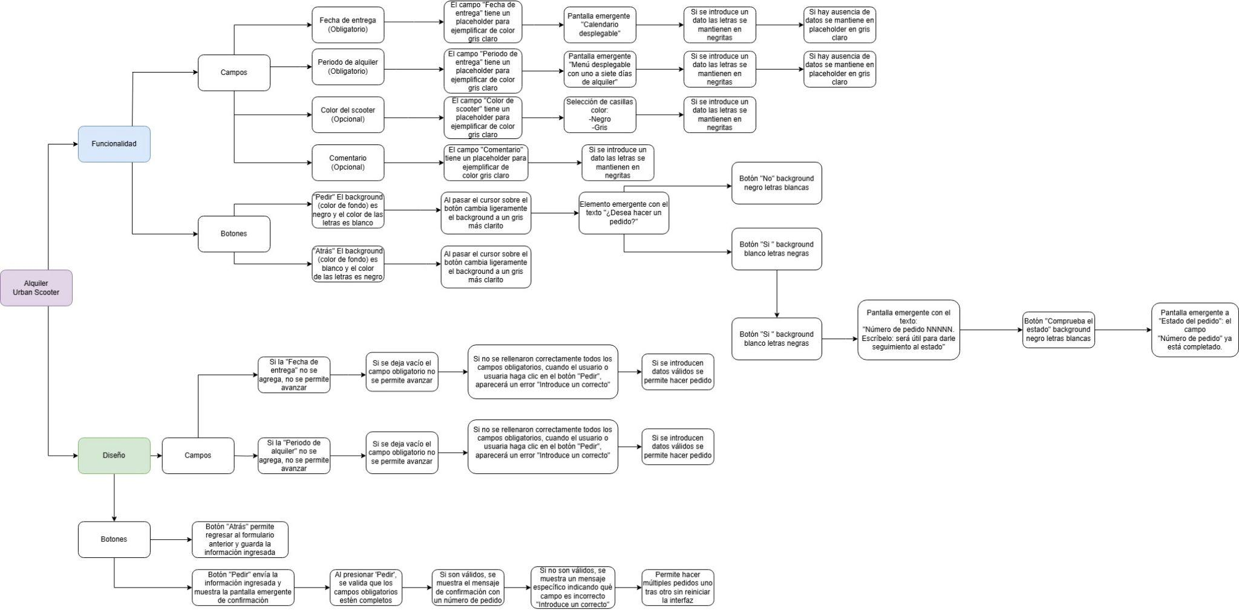

1. Enlaces a los informes de errores creados en Jira:

*Lista de comprobación tarea #2*

<https://marinitachii01.atlassian.net/browse/USB-1>

<https://marinitachii01.atlassian.net/browse/USB-24>

<https://marinitachii01.atlassian.net/browse/USB-5>

<https://marinitachii01.atlassian.net/browse/USB-25>

<https://marinitachii01.atlassian.net/browse/USB-7>

<https://marinitachii01.atlassian.net/browse/USB-26>

<https://marinitachii01.atlassian.net/browse/USB-23>

<https://marinitachii01.atlassian.net/browse/USB-27>

*Validación de datos tarea #2*

<https://marinitachii01.atlassian.net/browse/USB-9>

<https://marinitachii01.atlassian.net/browse/USB-13>

<https://marinitachii01.atlassian.net/browse/USB-11>

<https://marinitachii01.atlassian.net/browse/USB-12>

<https://marinitachii01.atlassian.net/browse/USB-14>

<https://marinitachii01.atlassian.net/browse/USB-15>

<https://marinitachii01.atlassian.net/browse/USB-16>

<https://marinitachii01.atlassian.net/browse/USB-18>

<https://marinitachii01.atlassian.net/browse/USB-19>

<https://marinitachii01.atlassian.net/browse/USB-20>

<https://marinitachii01.atlassian.net/browse/USB-21>

<https://marinitachii01.atlassian.net/browse/USB-22>

**Tarea 3: Aplicación móvil Urban Scooter**

1. Enlaces a los informes de errores creados en Jira:

<https://marinitachii01.atlassian.net/browse/USB-28>

<https://marinitachii01.atlassian.net/browse/USB-29>

**Tarea 4: API de la aplicación Urban Scooter**

1. Enlaces a los informes de errores creados en Jira:

<https://marinitachii01.atlassian.net/browse/USB-30>

<https://marinitachii01.atlassian.net/browse/USB-31>

<https://marinitachii01.atlassian.net/browse/USB-32>

<https://marinitachii01.atlassian.net/browse/USB-33>

<https://marinitachii01.atlassian.net/browse/USB-34>

<https://marinitachii01.atlassian.net/browse/USB-37>

<https://marinitachii01.atlassian.net/browse/USB-35>

<https://marinitachii01.atlassian.net/browse/USB-36>

<https://marinitachii01.atlassian.net/browse/USB-38>

<https://marinitachii01.atlassian.net/browse/USB-39>

<https://marinitachii01.atlassian.net/browse/USB-40>

<https://marinitachii01.atlassian.net/browse/USB-41>

<https://marinitachii01.atlassian.net/browse/USB-42>

<https://marinitachii01.atlassian.net/browse/USB-43>

<https://marinitachii01.atlassian.net/browse/USB-44>

<https://marinitachii01.atlassian.net/browse/USB-45>

<https://marinitachii01.atlassian.net/browse/USB-46>

<https://marinitachii01.atlassian.net/browse/USB-47>

<https://marinitachii01.atlassian.net/browse/USB-48>